**Project Increment - 2**

**CSEE 5590-0002: Web/Mobile Programming**

# **KC Donation Web Application**

# **Team 3**

## Roshna Toke, ClassID: 23

## Manaswini Vedula, ClassID: 24

## Yamini Saraswathi Bommineni, ClassID: 03

### **Motivation:**

Food is the primary essential need. Many people suffer from hunger because of a shortage of food and at the same time lots of excessive food has been wasted in the restaurants. So, the main motivation of this application is to create a bridge between the Donor and users and making excessive food to reach for the people who are in need.

### **Significance:**

The significance of this application is that it can fill the gap between the people having excessive food and people who are looking for food out of hunger. The people having excessive food like restaurants businesspeople can upload their excessive food into the Donor page after uploading the Users can find the food available for donating and can access that through the user's page as per their need.

### **Objectives:**

The main objective of this project is to design a system where donors (those who have excess food items) can donate their food items only by posting its description on the system and then the requester will request that as per their need and collect from a given address.

### **System Features:**

**Main Page**: Welcome Page of this application where User and Donor both can **Login** and **Register**.

**Donor**: On the donor page, the donor can add food items he wants to donate, delete added food items and he can see his history of food donation from starting

**Requester**: On the requester page, when the donor adds his food items then that food item will be visible to all requesters. Requesters can request that food item then it won’t be visible on requesters as well as donors page. Also, the requester can see his history from starting.

### **Demo Screens:**

1. **Main Page**

* **This is screenshot Main Page of the ‘KC Donation’ web application.**
* **This is single page for all functionalities.**
* **Here we have given ‘Sign-in’ and ‘Login’ functionalities. Also, all tabs – Home, Gallery, Contact us and About are working.**

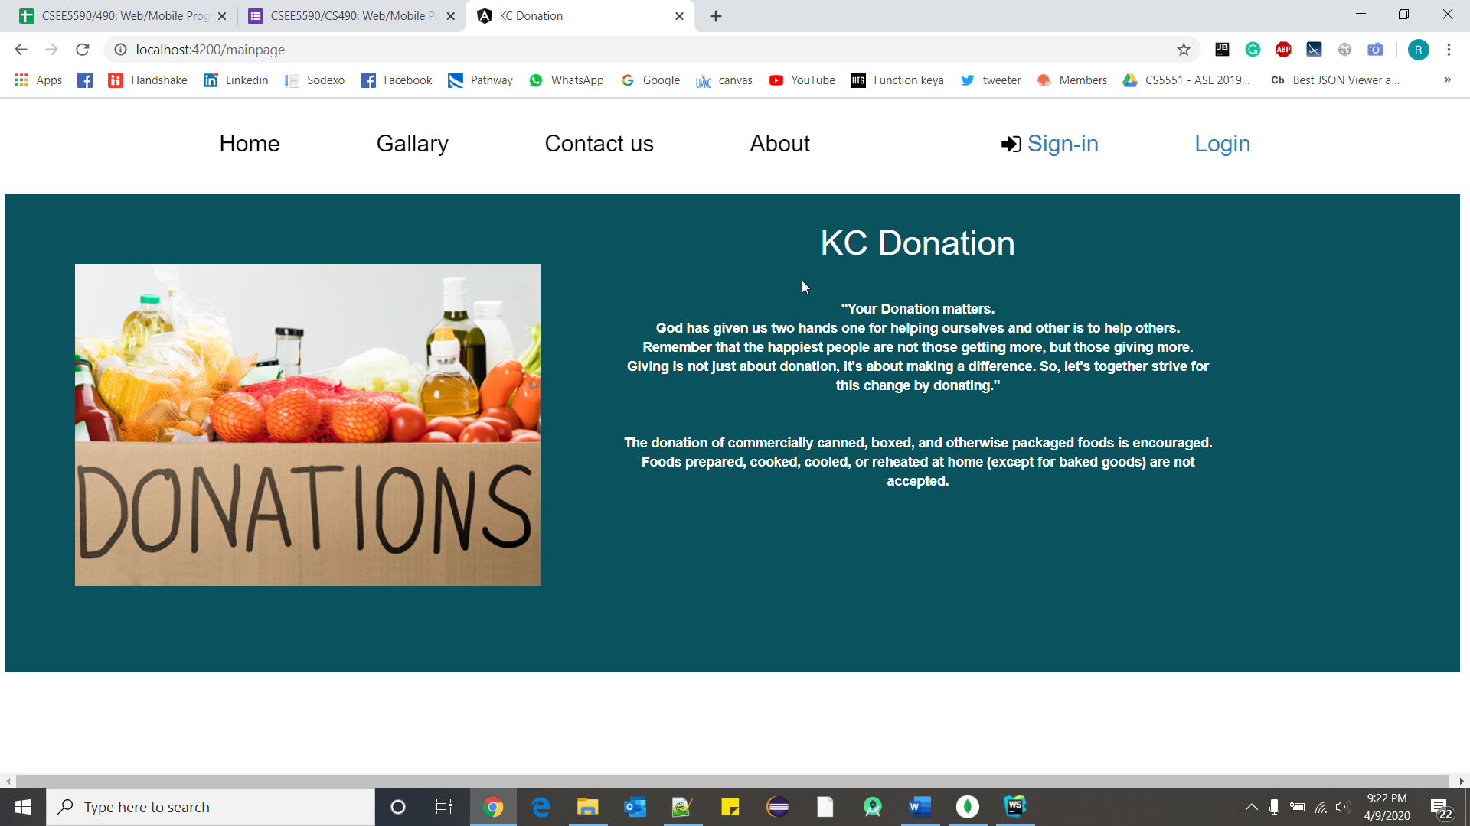

* **When user click on ‘Gallery’, it will scroll to here.**
* **Users can share their pictures with, we can post those in our gallery.**
* **This is just small try, so that it will encourage people to donate items.**

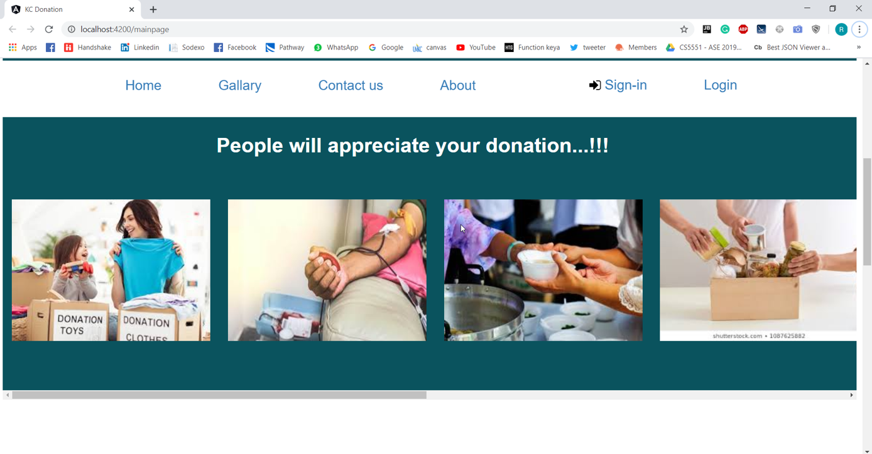

* **Users can contact us from this information.**
* **They care share their pictures via email to share on gallery, and encourage people.**

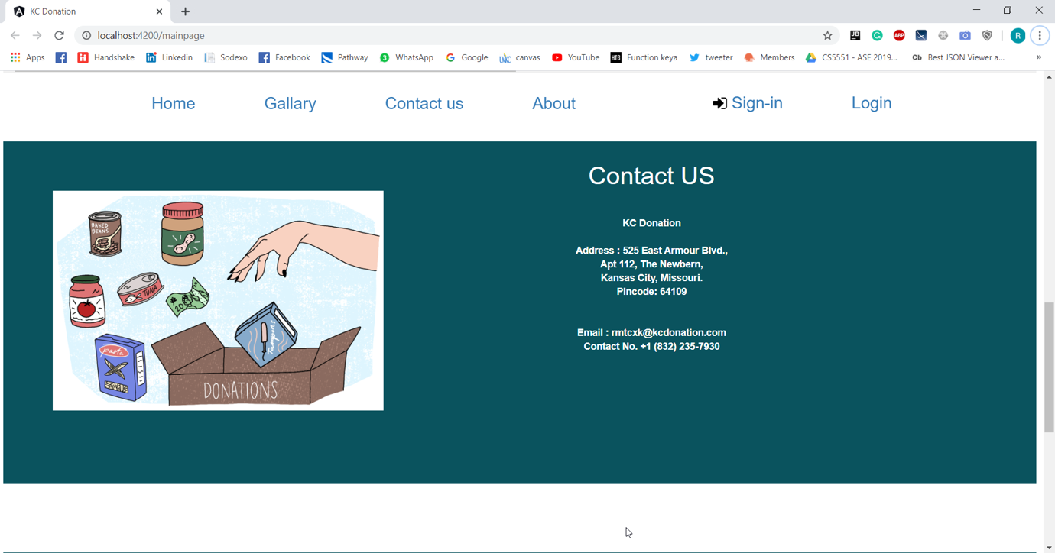

* **This is just an information of our team.**

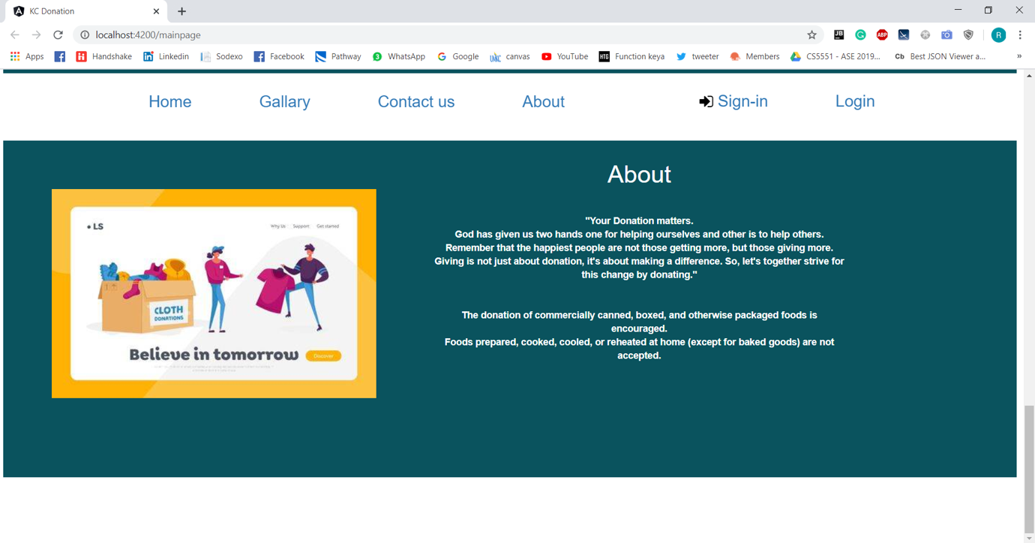

1. **Registration Page**

* **This is the screenshot of the registration page.**
* **First time user should sign up before he can login to the application and all the fields in this page are mandatory.**
* **We have also included some validations like both password and confirm password are same and check all the fields are filled up after the user clicks sign up.**
* **User type can be either ‘Donor’ or ‘Requestor’.**
* **User length should be greater than 3.**
* **Password length should be greater than 5.**

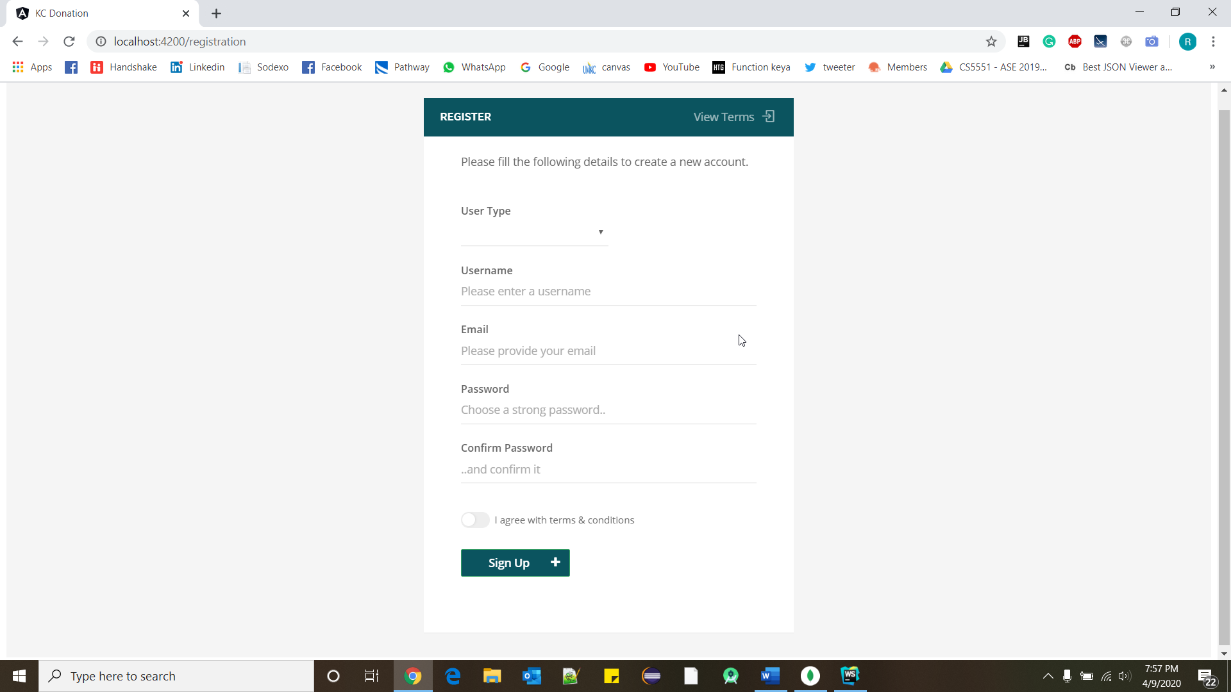

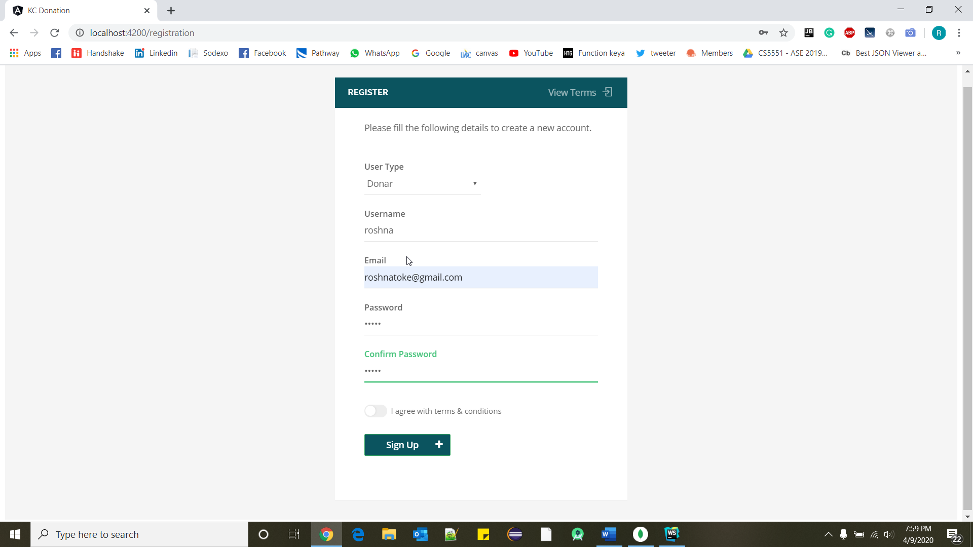

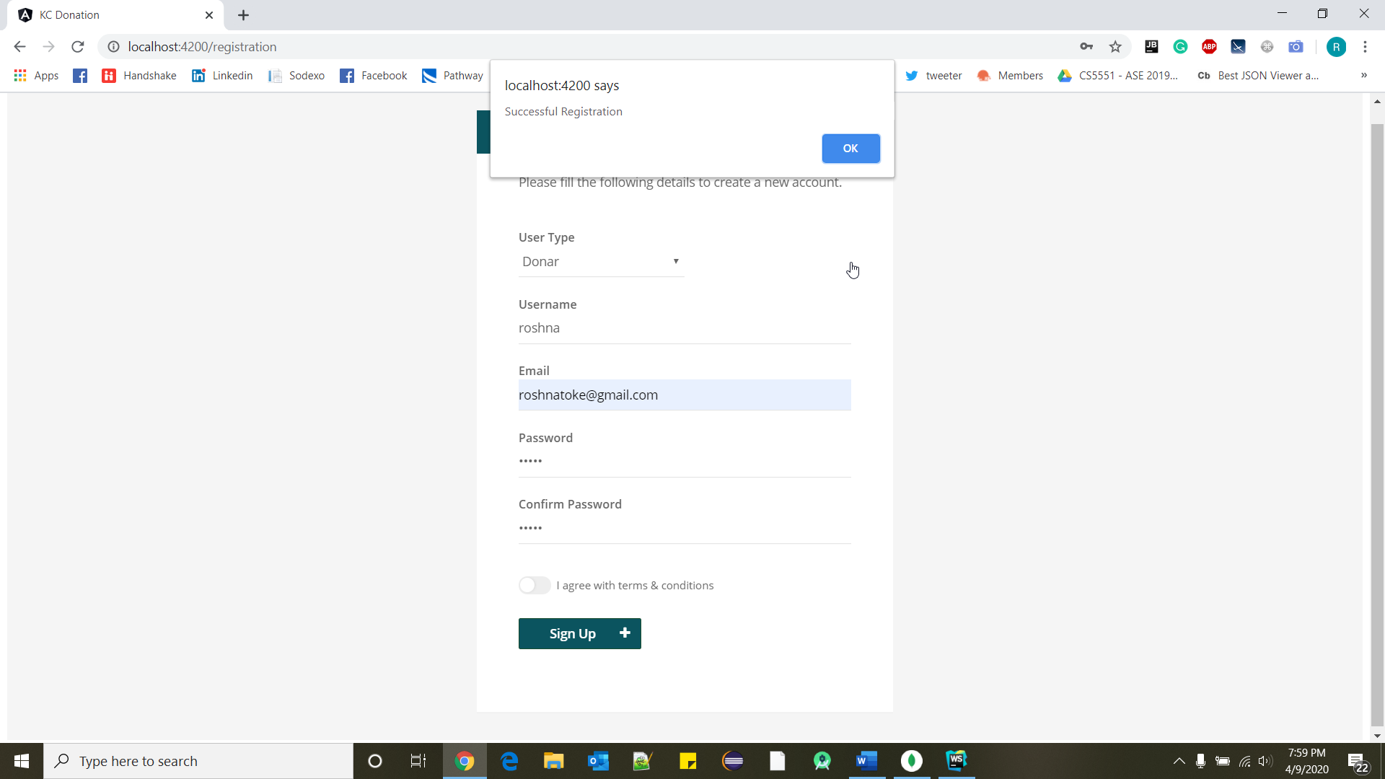

1. **Login Page**

* **This is the screenshot of the login page.**
* **Here as the user enters his/her details it will check automatically if the credentials match with any of the users who have registered and if it matched it navigates to home page.**
* **If the credentials do not match then it prompts that username or password is wrong.**

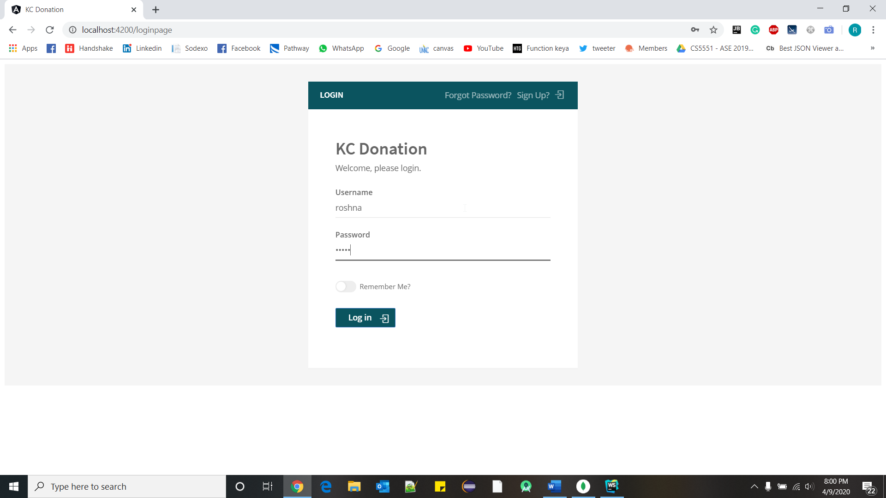

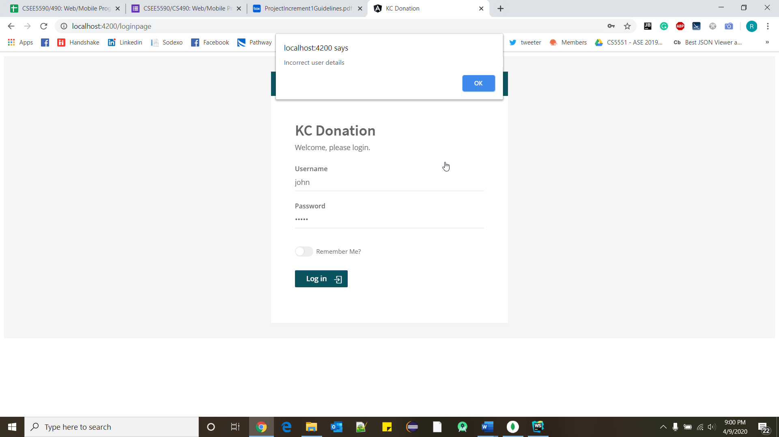

1. **Forgot Password**

* **If the user forgets his/her password, then by clicking forgot password button he will be navigated to this page.**
* **Here as the user enters his email and clicks send email then an email with a new password will be sent to users account.**

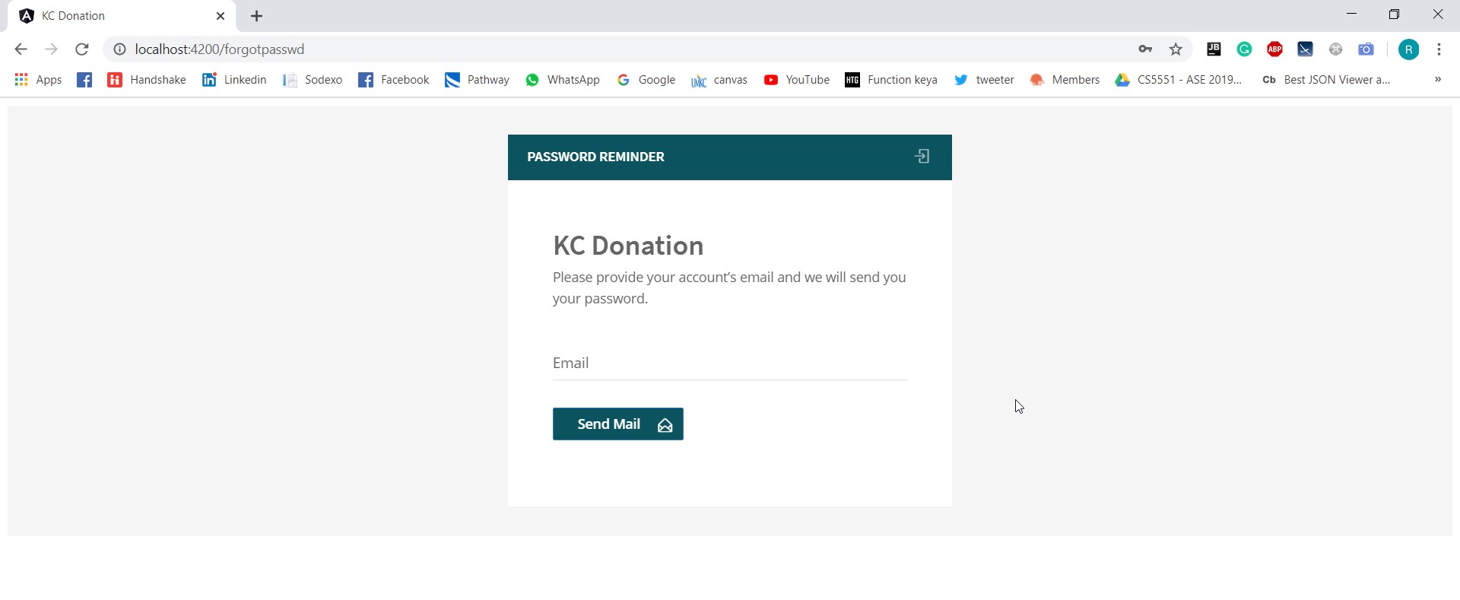

1. **Donor Page**

* **In Donor page we have given two buttons, one is for donation and another one is for seeing history of user’s donation.**
* **When user click on ‘Donate’, new window will open and he can fill data of item which he/she wants to donate.**
* **When users click on ‘History’ button, he can see history of his donated item.**
* **Some food which had been requested already, so can see name of requester person and date in history table.**
* **When user click on logout button it will re-direct to main page of the application.**

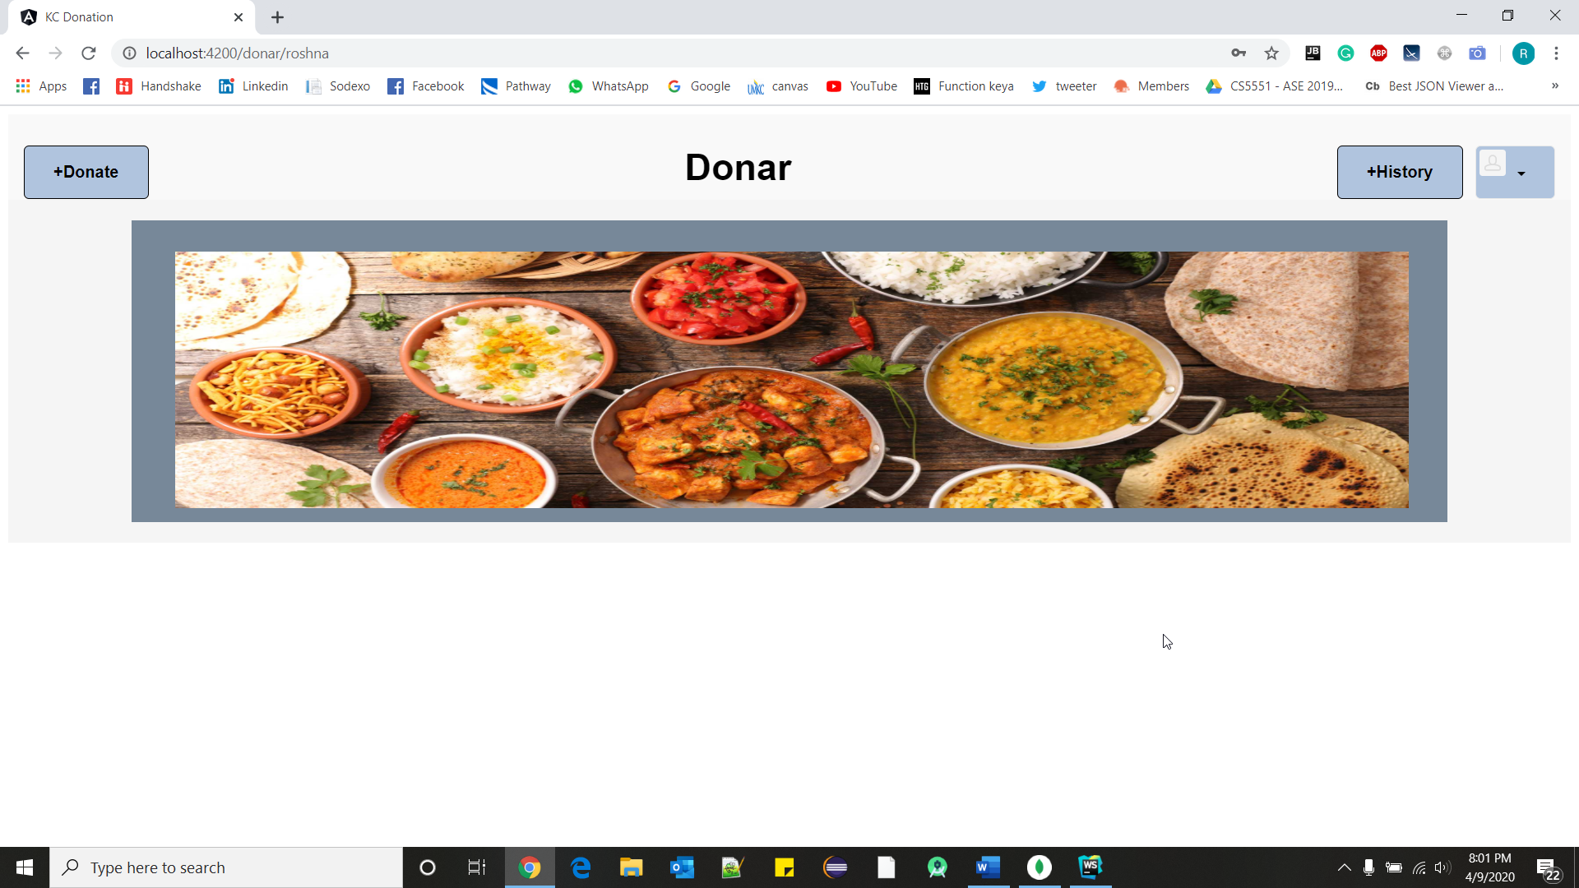

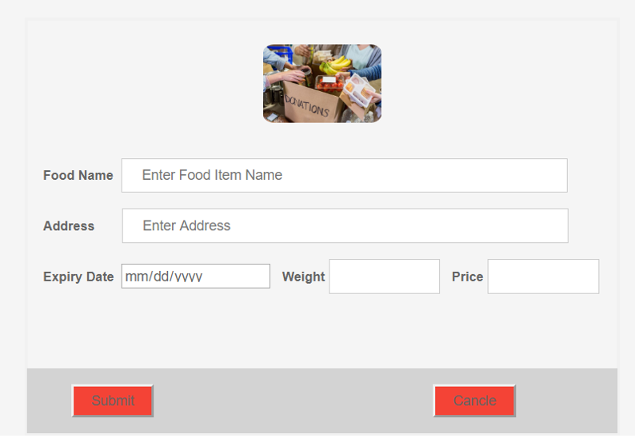

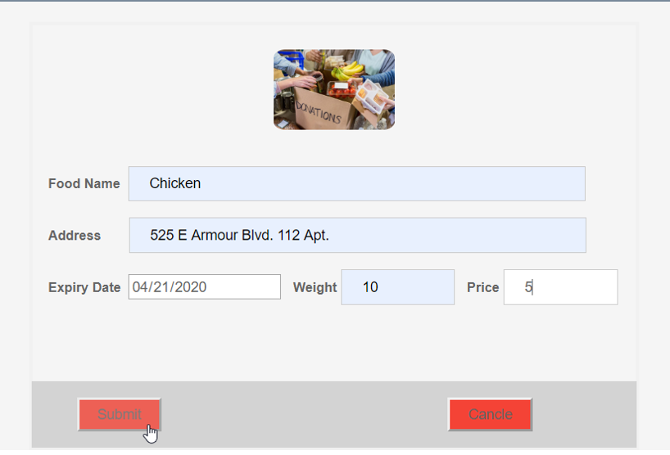

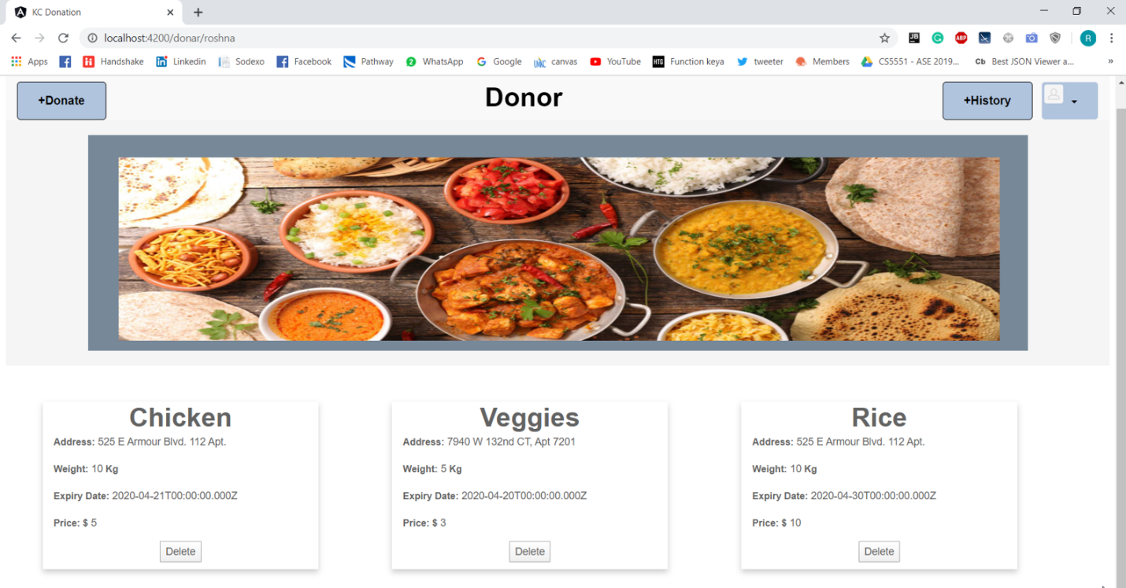

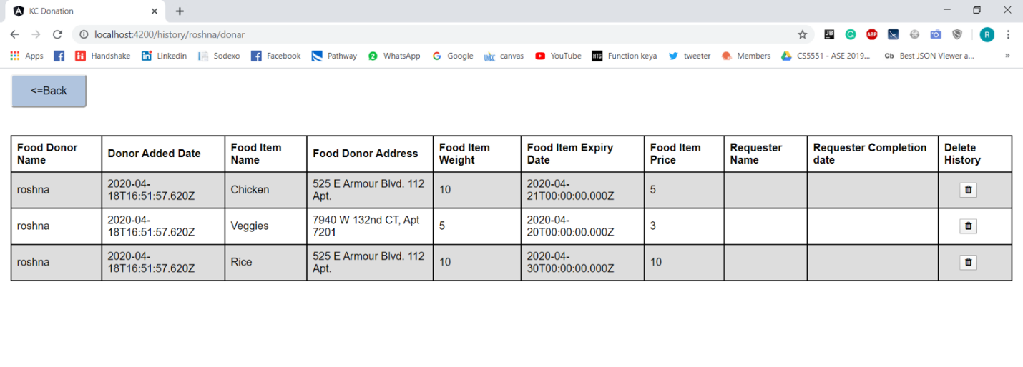

* **After clicking on profile button, user can change his email-id or password.**

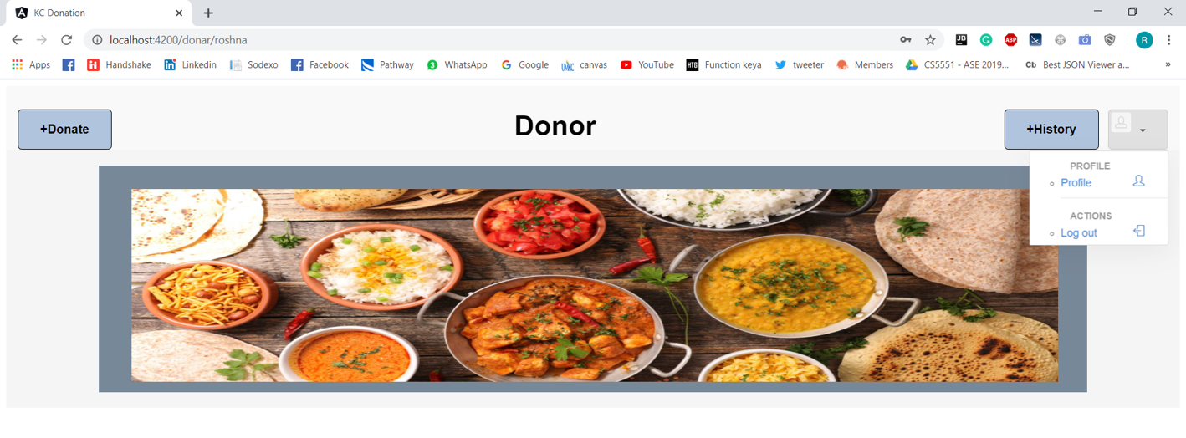

1. **Requester Page**

* **This is requestor page.**
* **Here we have given history button for requestor to see his history.**
* **Whatever donor will add in his window, requester can see those item in his bucket.**
* **When requester click on ‘History’ button, he can see items which he has requested in the past with requested date.**
* **When user click on logout button he/she will redirect to main page of the application.**

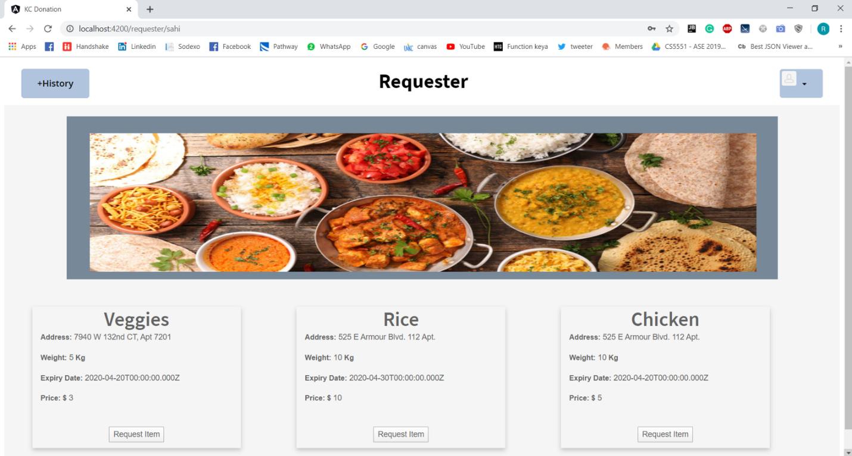

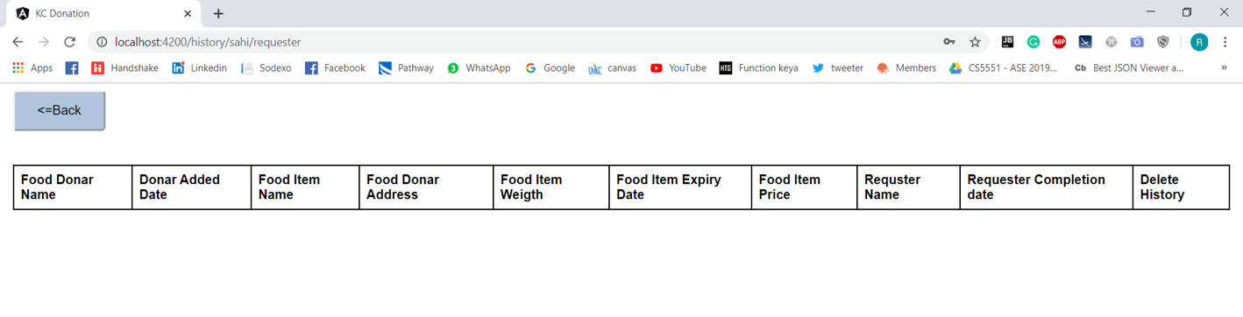

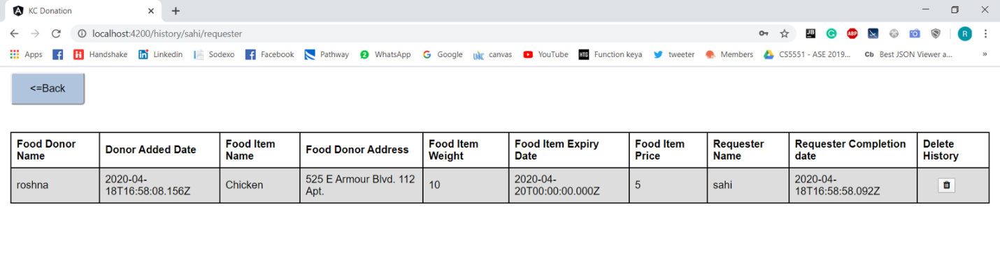

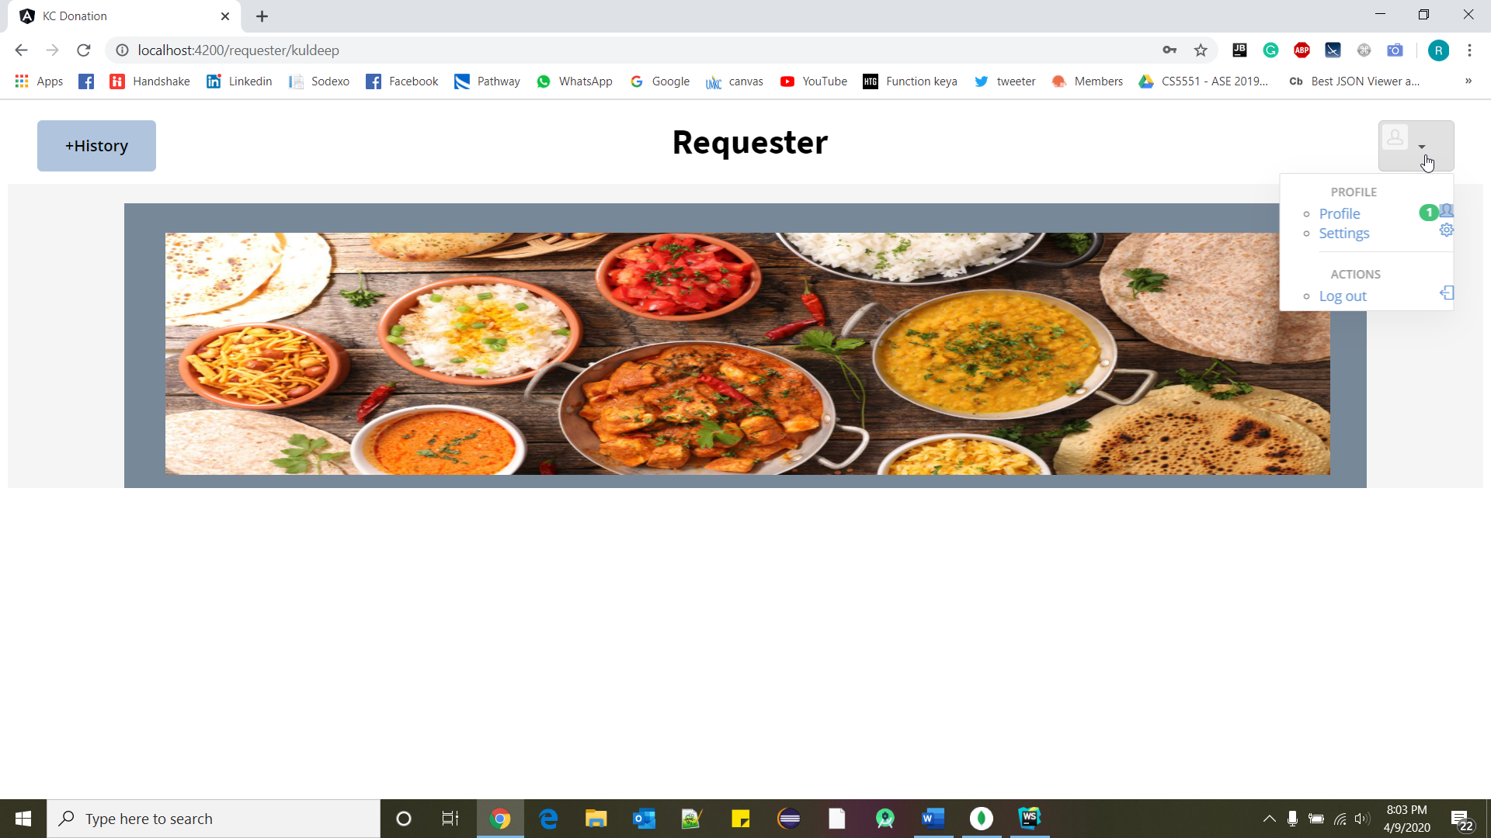

1. **Database:**

* **We have created 3 tables for our application.**
* **User table is to store donors and requester information with their respective user-type and password.**
* **Food data table to store all items, which donor has added and to delete which requester is requesting.**
* **History table is to store all the actions of donors as well as requesters with their respective date and time.**

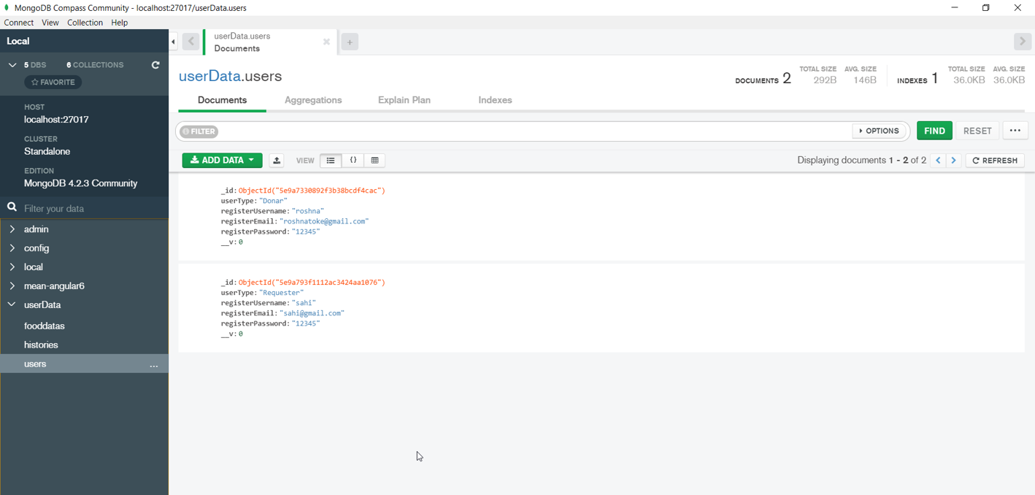

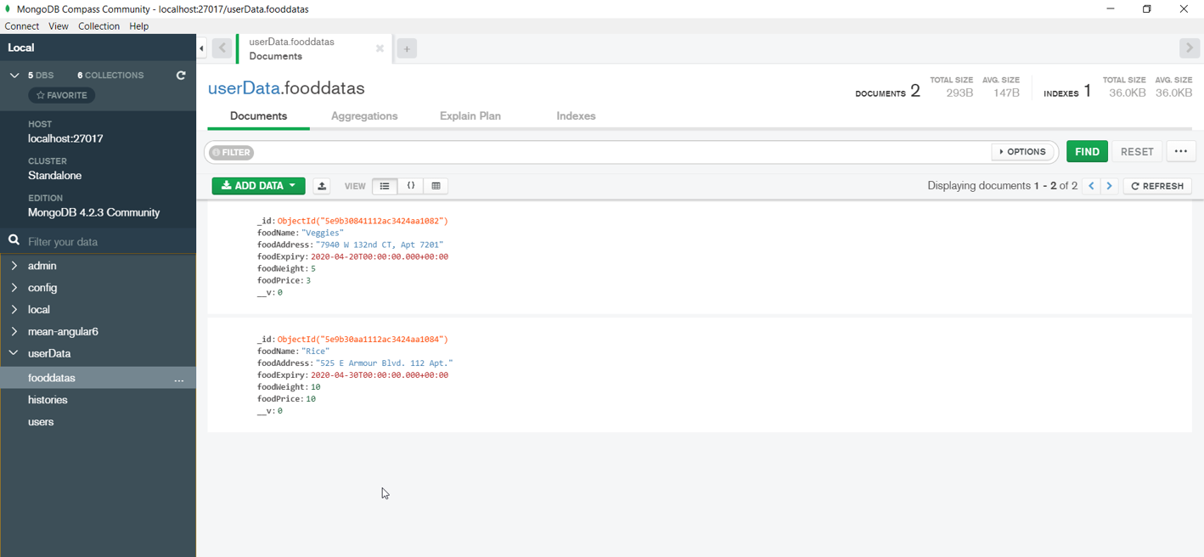

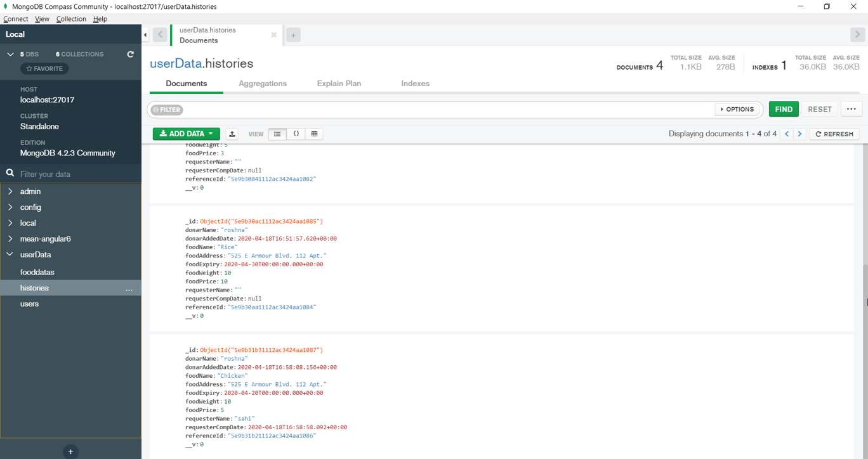

### **Improvement from the Increment 1:**

1. Completed Main page functionality of the application. All tabs are working.
2. Donor Page functionality, donor can add item which he wants to donate.
3. Donor can see history of items whichever he has donated, with person name who requested that item.
4. Requester can see items donated by donors and he/she can request that item.
5. When requester request item from list, then history table gets update and he can see his entry in history.

### **Things need to be done:**

1. If user forget his/her password, then email with random password.

2. If user wants to change email id/password, then after clicking on ‘profile’ he should be able to do.

3. When donor will add item for donation list, then all requesters will get an email notification.

4. Generalization of an Application.

5. GUI Improvement.

### **GitHub Link:**

### <https://github.com/roshna1924/KC-Donation>

### **Work sharing between teammates:**

All are equally working in developing functionalities and designing webpages.

### **Technologies used:**

MEAN stack

Angular JS

HTML, CSS, Bootstrap

Node JS

Mongo DB

### **References:**

Hackathon Use Case - <https://umkc.app.box.com/s/gg46llw7gye4is7ujhohw00a2sody7mb>

<https://www.w3schools.com/>

[www.google.com](http://www.google.com)

<https://mongoosejs.com/docs/api.html>